**UNIT 9 PREVIEW**

**(D) UNDERSTANDIDIOMS AND EXPRESIONS**

**1. It´s not understandable or clear.**

**2. It disappears completely.**

**3. He´s makes the wrong assumption about something.**

**4. He or she has very different opinion than other people about something or does something very differently.**

**5. He or she doesn´t believe it´s true.**

**6. It´s unlikely or improbable.**

**SPEAKING**

**(A) PAIR WORK**

**- Vaccines are to prevent diseases; it has nothing to do with the physical form of children.**

**- It doesn't make sense because each country is economically independent.**

**- We don't believe it's true, because we have not confirmed that life exists on other planets.**

**- Because there is evidence such as photos, videos, and information that affirm it did happen.**

**UNIT 9 LESSON 1**

**UNIT 9 LESSON 2**

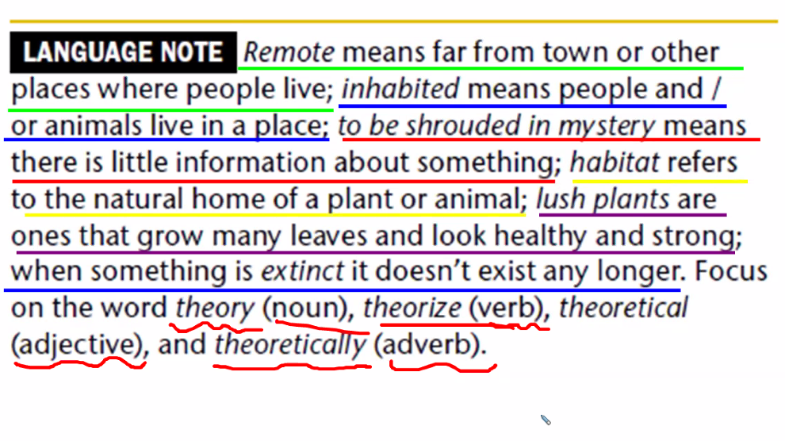

**(B) DRAW CONCLUSION**

Because I don't believe that the "Moai" had a life of their own and could move by themselves.

For me, the most credible theory is that the settlers placed them horizontally and rolled them on tree trunks to transport them more easily, but it was still a lot of work, which is why more than 70 people and several days were needed to complete it.

**(E) GRAMMAR PRACTICE**

Heyerdahl thought **they might have come** on a raft like the Kon-Tiki.

Some historians think that **the Rapa Nui islanders could not have moved** the moai using logs.

**It’s possible someone may have forced the pilot** to fly the plane to a different location

Experts suggest that originally **the Rapa Nui people must have written** on banana leaves.

**Hunting had to have been** the cause of the carrier pigeon´s extinction as a species.

UNIT 9 LESSON 3

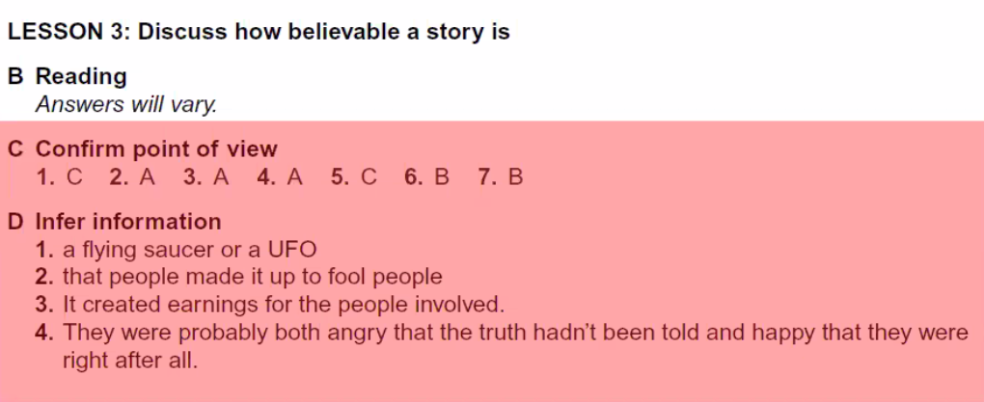

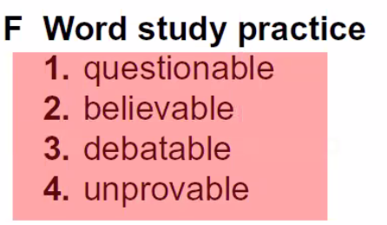

**UNIT 9 LESSON 4**

**Review**

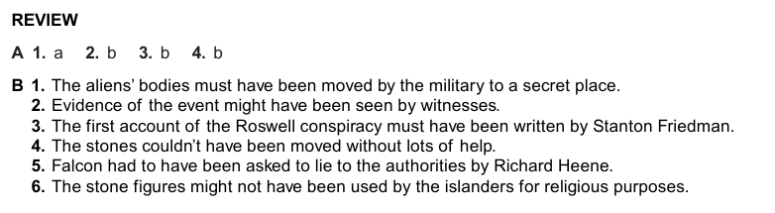

**It's possible, because according to what I've heard, the Yeti is like a big, tall gorilla with white fur. Maybe it's an unknown species of animal that lives in the forested areas of the Himalayan mountain range.**